WC Division of Aging & Disability Services  1-877-222-3737  908-475-6591 | 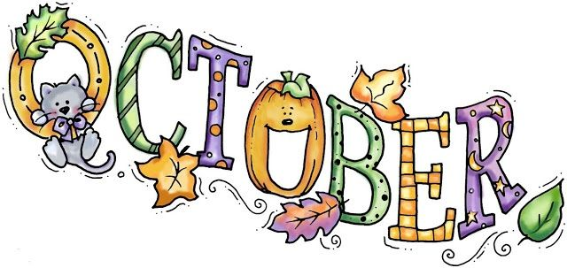 2023  Warren County Community Senior Center Lunch Menu |  |  |  |  | 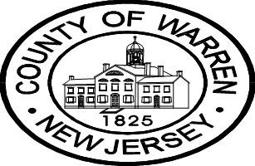
 | Monday | Tuesday | Wednesday | Thursday | Friday
Centers Locations | 2 | 3 | 4 | 5 | 6 | 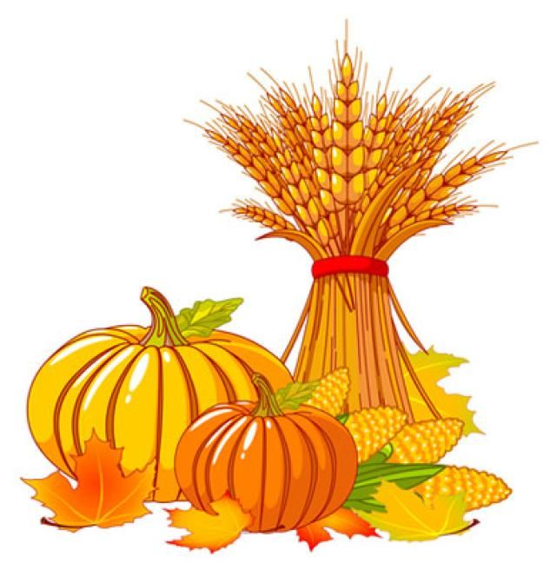  Grab & GO HOT meals are available for pick up  Please call 24 hours in advance to make your reservation.  Suggested donation  Age 60+ - $3.00  Under Age 60 –  $6.85Fee  MENU SUBJECT TO  CHANGE
Phillipsburg Senior Center  310 Firth Street  Phillipsburg, NJ  (908) 859-2423 | Minestrone  (2X) Beef Hotdog’s w/ Sauerkraut  Mustard, Ketchup, Relish  Potato Wedges  Peas w/ Red Peppers  (2X) Hotdog Buns  Melon Slices | Vegetarian Chili  Rice  Brussels Sprouts  Tossed Salad w/ Dressing  Pumpernickel Slice  Granola Bar | Chicken Rice Soup  Stuffed Pepper  Mashed Potatoes  Lima Beans  Dinner Roll  Vanilla Ice Cream Cup (Congregate)  Pudding Cup (HDM) | Split Pea Soup  Teriyaki Chicken Meatballs  Jasmine Rice  Asian Vegetable Blend  WW Dinner Roll  Mandarin Orange Cup | Cran-Apple Juice  Beef Bourguignon  Mashed Potatoes  Sugar Snap Peas w/ Peppers  Spinach Salad w/ Honey Mustard  Dinner Roll  Pears w/ Cinnamon
 | ALL SITES CLOSED TODAY 9 | 10 | 11 | 12 | 13
Faith Discovery Church  33 Brass Castle Rd  Washington, NJ  908-689-0650 |  | Pineapple Juice  Crab Cakes w/ Tartar Sauce  Potato Wedges  Zucchini w/ Sauce  Pumpernickel Slice  SF Gelatin | Creamy Sweet Potato Soup  Chicken Cacciatore  Pasta w/ Sauce  Sauteed Spinach  Tomato Onion Salad  Italian Slice  Fruited Yogurt | Chicken Soup  Pepper Steak  Basmati Rice  Asian Vegetable Blend  Dinner Roll  Baked Apple w/ Cinnamon | Turkey Meat Loaf  w/ Red Pepper Cream Sauce  Stuffing  Green Beans Almondine  Black Bean & Corn Salad  Rye Slice  Chocolate Ice Cream Cup (Congregate)  Pudding Cup (HDM)
 | 16 | 17 | 18 | 19 | 20
Hackettstown Senior Center  293 Main Street  Hackettstown, NJ  908-850-5438 | Squash Soup  Potato Crusted Fish w/ Tartar  Macaroni and Cheese  Stewed Tomatoes  Broccoli Slaw  Raisin Bread Slice  Orange | BBQ Shredded Brisket  Hot German Potato Salad  Sauteed Mixed Greens  Carrot Raisin Salad  Hamburger Roll  Fruited Yogurt | Tomato Rice Soup  Roast Turkey w/ EXTRA Gravy  Corn Bread Stuffing  Green Bean Almondine  Cranberry Sauce  Dinner Roll  Vanilla Ice Cream Cup (Congregate)  Pudding Cup (HDM) | Orange Juice  Navy Bean Soup  Chicken Salad  Beet and Onion Salad  Black Bean Salad  Rye Slices  SF Gelatin Cup | Pork Chop  Scalloped Potatoes  Red Cabbage w/ Apples  Romaine w/ Mandarin Oranges & Dressing  Corn Muffin  Tapioca Pudding
 | 23 | 24 | 25 | 26 | 27
Knowlton Lions Den  505 Route 94  Columbia, NJ  908-496-4001 | Beef Barley Soup  Turkey Sausage  Pierogies w/ Sauerkraut & Sour Cream  Hot Beets  Rye Slice  Pudding Cup | Apple Juice  Roast Pork Loin w/ EXTRA Gravy  Mashed Potatoes  Peas w/ Red Peppers  Three Bean Salad  Dinner Roll  Apple Crisp | Broccoli Cheese Soup  Hamburger w/Lettuce Tomato, Onion, Pickle & Ketchup Packets  Home Fried Potatoes  Mixed Vegetables  Hamburger Roll  Chocolate Ice Cream Cup (Congregate)  Pudding Cup (HDM) | Lentil Soup  Stuffed Shells w/ EXTRA Sauce  Sausage  Creamed Spinach  Italian Slice  Seasonal Stone Fruit | Hungarian Goulash  Noodles  Stew Vegetables  Tossed Salad w/ Dressing  Rye Slice  Birthday Cake (Congregate)  SF Gelatin (HDM)
 | 30 | Happy Halloween 31
 | Cream of Broccoli Soup  Eggplant Roulette w/ EXTRA Sauce  Pasta Marinara  Sauteed Mixed Greens  Sugar Free Gelatin Cup  Italian Slice  Fruited Yogurt | Italian Sausage w/ Peppers & Onions  Italian Sliced Potatoes w/ Sauce  Italian Green Beans  Anti-Pasto Salad  Hoagie Roll  Tropical Fruit Cup  BIRTHDAY CAKE |  | PLEASE REMEMBER TO REDEEM YOUR FARMER MARKET BENEFITS BEFORE NOVEMBER 30TH | 