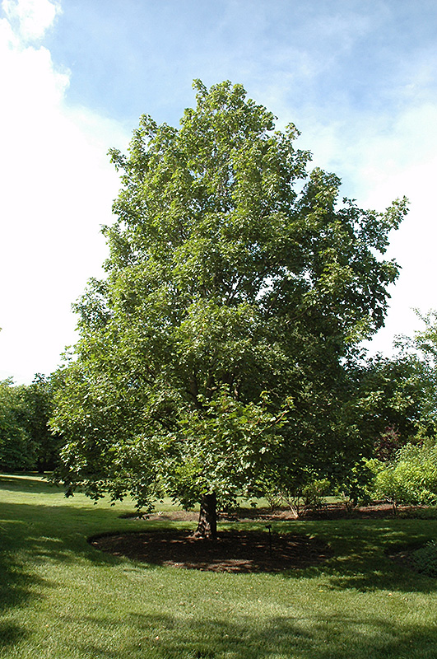

**Hedge Maple**

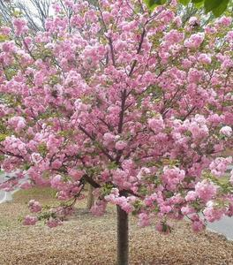

**Red Maple Snow Goose Cherry**